**BIEN 401/501: Mass Transport**

**2025 Project**

Progress Report 1

This is a team assignment. You may work in teams of 2 students (3 with permission from the teacher).

You are tasked to design, model, fabricate, and verify a 2D microfluidic concentration gradient generator. As discussed through your courses, microfluidic systems are characterized by small Reynolds numbers given the small aspect ratios used. Because of this flow characterization, mixing two fluids can present challenges. Microfluidic concentration gradient generators (CGGs) have been designed and used to generate unique concentration profiles that have many applications. These devices come in various shapes, designs, and my use different fabrication techniques in their development.

This project will be broken into 3 stages: Discovery, Fabrication, and Validation.

**Discovery**

Using examples from the literature to serve as a guide, you will be tasked with designing a CGG that can fit on a microscope slide (roughly 1 inch x 3 inches). Using COMSOL check and optimize your design to get the desired concentration gradient (the uniqueness/complexity of your gradient will factor into your grade). You are encouraged to be creative with your design (but keep in mind how the device will ultimately be fabricated). Through your literature review, note the ways that CGGs are currently used in the microfluidic field and possibly present potential applications where they could be used. A few articles have been provided to help you get started (but you should expand your search beyond the articles provided).

**Progress Report 1**

You should have a few design iterations that you have tested (at least one design per team member). In addition to the geometry of the channels, you may also experiment with inlet flowrates (within a specified range). You will provide a summary report showing your designs and the generated concentration profiles in the viewing window. You should include both a 2D surface map of the profile and a 1D line graph of the profile traveling across the viewing window (perpendicular to the flow field). Include in your report these figures and any information that you find important for your design. Limit the size of your final submission to 3 pages per person (e.g., a 2-person group may submit a 6-page file; title page does not count).

**Helpful tips**

When setting up the physics for your model, you will need **Transport of Diluted Species (tds)** and **Laminar Flow (spf)**. A stationary study is all you really need, but if you interested (or concerned) about how long it takes the device to reach steady state, a time-dependent study can be added (this will take longer than the stationary model).

The model geometry can be created in COMSOL or other CAD software (e.g., SolidWorks). If using another software (like SolidWorks; create a part file and start with a 2D sketch), save the design as a DXF file. You can then **import** the DXF file into COMSOL.

Remember for the TDS physics to select the box for convection and under **Transport Properties 1** be sure to use the velocity field from the SPF solution.

Under **Laminar Flow**, check the box next to “Use shallow channel approximation”; for the channel thickness enter 150 micrometers (i.e., 150[um]). As the flow velocities should be relatively slow, you might find checking the box by “Neglect inertial term (Stokes Flow)” useful (note: this will change Laminar Flow into Creeping Flow).

An example of a CGG device (not necessarily a good one) is shown below.

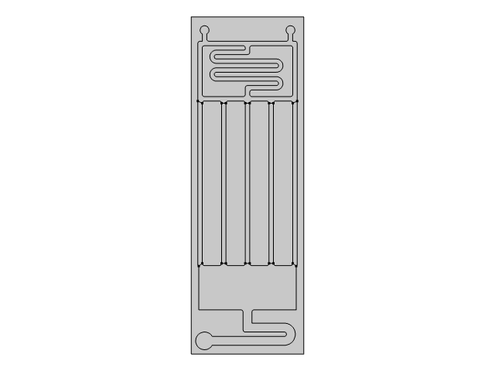

You should have two inlets (one for the concentrated solution and one for the dilute solution). It is suggested that you use a fully developed flow rate condition. Flow rates can vary from 0.05 to 0.3 mL/min (or cm3/min). Make sure you also set two distinct inflow concentration conditions.

Serpentine channels are commonly used to promote mixing given their longer effective lengths. The number of turns may be dependent on the flow rates used. You may also use other techniques to promote mixing including inserting flow disrupting obstacles. But keep in mind how the device will be fabricated.

You should create a “viewing window” near the exit of your device. This is where we will monitor the concentration gradient profile. Using a wide window allows for better resolution when we ultimately take pictures and analyze it using MATLAB. Either a line segment can be drawn across (not shown) or a Cut 2D line can be used (in the results module) to make the 1D concentration line graph profile.

Since there is one outlet and two inlets, it is strongly recommended to double the size of the outlet (relative to your inlets). This prevents pressure buildup in the device and allows the fluid to leave in an equally slow manner.

You may want to adjust channel widths throughout the device to affect mixing ratios. Bifurcation angles and areas of daughter branches will affect the flow rates downstream.

Individual and temporary walls can be inserted as you explore your model. You can isolate regions (domains) and remove them from the physics (i.e., they effectively become part of the background). You may discover unique profiles when “turning off” specific channels.

Remember the device must fit on a 3-inch x 1-inch microscope slide. You are encouraged to draw a 3x1 rectangle (double-check units) to guide your design. You may discover during fabrication and testing that you may need larger gaps for the tape or other modifications to make your design ultimately work.

Example Figures

